**WEED DETECTION**

A Project Report

Submitted in the partial fulfilment on the requirements for

the award of the degree of

Bachelor of technology

In

Department of Computer Science And Engineering

By

L. VAMSI KRISHNA (2010030410)

T. SAINATH (2010030383)

V. ABHIRAM (2010030174)

Under the supervision of

**DR. RAMARAO**

ASSISTANT PROFESSOR



Department Of Computer Science And Engineering

Kl University Hyderabad, Aziz Nagar, Moinabad Road, Hyderabad – 500075, Telangana, India.

March 2022

**DECLARATION**

The Project Report entitled “WEED DEECTION” is a record of bonafide work of <L.VAMSIKRISHNA(2010030410) T.SAINATH(2010030174) V.ABHIRAM(2010030383)>, submitted in partial fulfilment for the award of B. Tech in the Department of Computer Science and Engineering to the K L University, Hyderabad. The results embodied in this report have not been copied from any other Departments/University/Institute

<signature of the students

V ABHIRAM

T SAINATH REDDY

L VAMSI KRISHNA

## CERTIFICATE

This is to certify that the Project Report entitled “WEED DETECTION” is being submitted by V.ABHIRAM(2010030383) T.SAINATH(2010030174) L.VAMSI KRISHNA(2010030410) submitted in partial fulfillment for the award of B. Tech in CORONA HACK CHEST X-RAY to the K L University, Hyderabad is a record of bonafide work carried out under our guidance and supervision.

## Signature of the Supervisor

## 

Dr. Anal Paul

**Signature of the HOD Signature of the External Examiner**

**ACKNOWLEDGEMENT**

First and foremost, we thank the lord almighty for all his grace & mercy showered upon us, for completing this project successfully.

We take grateful opportunity to thank our beloved Founder and Chairman who has given constant encouragement during our course and motivated us to do this project. We are grateful to our Principal **Dr. L. Koteswara Rao** who has been constantly bearing the torch for all the curricular activities undertaken by us.

We pay our grateful acknowledgement & sincere thanks to our Head of the Department **Dr. Chiranjeevi Manike** for her exemplary guidance, monitoring and constant encouragement throughout the course of the project. We thank **DR. RAMA RAO** of our department who has supported throughout this project holding a position of supervisor.

We whole heartedly thank all the teaching and non-teaching staff of our department without whom we won’t have made this project a reality. We would like to extend our sincere thanks especially to our parent, our family members and friends who have supported us to make this project a grand success.

**ABSTRACT**

Weeds are one of the most important factors affecting agricultural production. The waste and pollution of farmland ecological environment caused by full-coverage chemical herbicide spraying are becoming increasingly evident. With the continuous improvement in the agricultural production level, accurately distinguishing crops from weeds and achieving precise spraying only for weeds are important. However, precise spraying depends on accurately identifying and locating weeds and crops. In recent years, some scholars have used various computer vision methods to achieve this purpose. This review elaborates the two aspects of using traditional image-processing methods and deep learning-based methods to solve weed detection problems. It provides an overview of various methods for weed detection in recent years, analyses the advantages and disadvantages of existing methods, and introduces several related plant leaves, weed datasets, and weeding machinery. Lastly, the problems and difficulties of the existing weed detection methods are analysed, and the development trend of future research is prospected.

**TABLE OF CONTENTS**

* 1. Introduction
  2. Literature Survey
  3. Hardware & Software requirements
  4. Methodology
  5. Flowchart
  6. Implementation
  7. Results Discussion
  8. Conclusion and Future Work
  9. References

**INTRODUCTION**

Weeds are an all too common occurrence in lawns and gardens. While some may be deemed useful or attractive, most types of weeds are considered a nuisance. Learning more about weed control and detection can make it easier for gardeners to decide whether these weeds should be welcomed or if they must go. Let’s take a look at some common weed plants and when or what weed control methods may be necessary. By definition, a weed is known as “a plant in the wrong place.” For the most part, these plants are known more for their undesirable qualities rather than for their good ones, should there be any. Weeds are competitive, fighting your garden plants or lawn grass for water, light, nutrients and space. Most are quick growers and will take over many of the areas in which you find them. While most types of weeds thrive in favourable conditions, native types may be found growing nearly anywhere the ground has been disturbed. In fact, they may even offer clues to your current soil conditions.

One of the newest and most researched technologies nowadays is deep learning. Deep learning is a technique used to create intelligent systems as similar as possible to human brains. It has made a big impact in all types of domains such as video, audio and image processing. On the other hand, agriculture is humanity’s oldest and most essential activity for survival. The growth of population during the last years has led to a higher demand of agricultural products. To meet this demand without draining the environmental resources the agriculture uses, automation is being introduced into this field. The present project aims to merge both concepts by achieving autonomous weed recognition in agriculture this goal will be reached by using new technologies such as Open CV, Farm Bot and Python programming, image processing, deep learning and Artificial Neural Networks (ANNs).

**LITERATURE SURVEY**

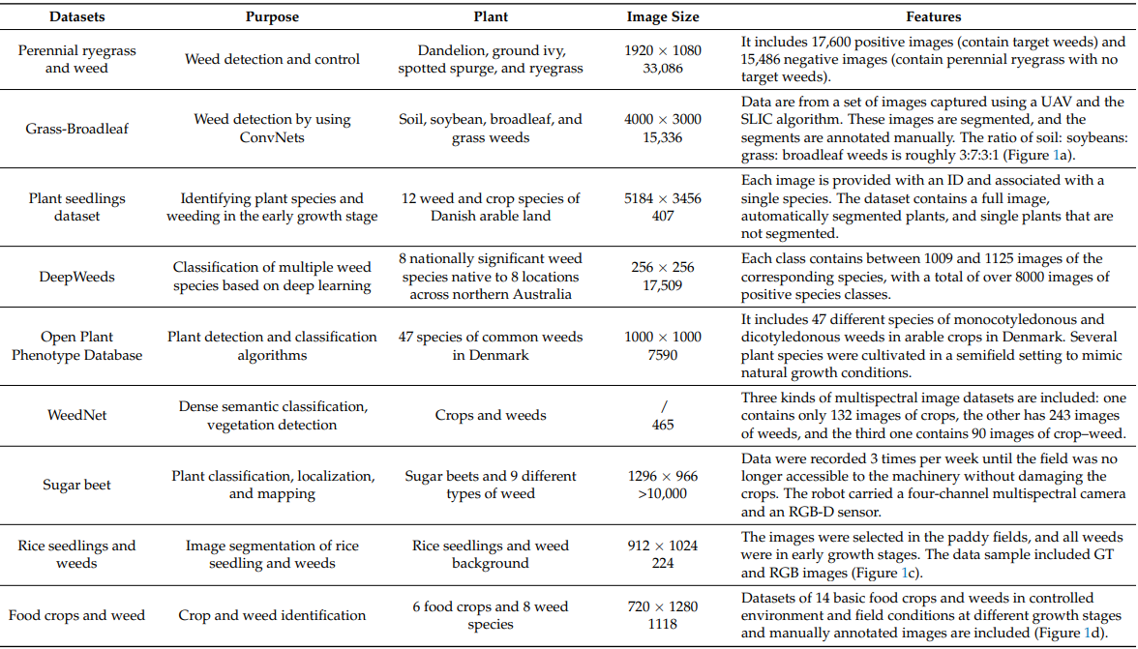

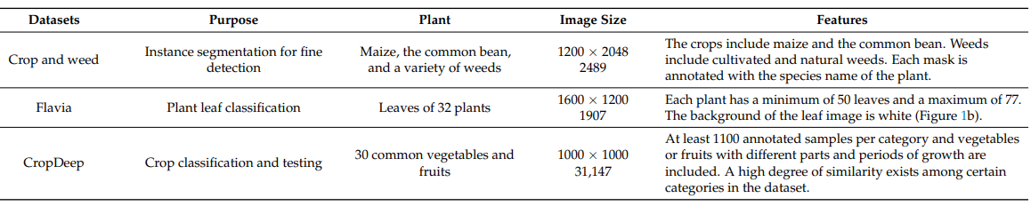

**IMPLEMENTATION**

**Setting up GPU :**

**Step-1 :** Clone darknet repo

**Step-2 :** Change makefile to have GPU and OPENCV enabled

**Step-3 :** Verify CUDA

**Step-4 :** Make darknet (build)

**Step-5 :** Define helper functions

**Step-6 :** Use this to upload files

**Step-7 :** Use this to download a file

**Mounting google drive for data**

**Step-8 :** Mounting google drive

**Step-9 :** This creates a symbolic link so that now the path /content/gdrive/My\ Drive/ is equal to /mydrive

**Step-10 :** From github copy all file from crop_weed_detection_training folder and make Agriculture (same name requires) folder and paste.

**CONCLUSION AND FUTURE WORK**

Further research on semi- or unsupervised feature learning will be a hotspot of weed detection in the future. Researchers have obtained good results in diverse specific background, but they still lack generality and robustness. Deep learning-based methods show an encouraging promise, but the large number of labeled samples increases the manual requirements. The verification and comparison of new development algorithms also require sufficient sample size and corresponding ground truth datasets. Compared with various weeds, field crop images are relatively easy to obtain. In view of the above reasons, weed detection methods based on semi- or unsupervised feature learning will continue to be a popular research topic in the future. With the use of the technology of weed detection and accumulation to develop an automatic crop guidance system, agricultural operations can be carried out in various aspects, such as harvest, weeding, spraying, and transportation. Automatically guided agricultural vehicles do not fatigue and reduce the labor intensity of the operator, thus improving efficiency and safety. However, at present, few methods

and devices meet the high requirements of practical applications. Considerable work should be done to develop equipment with high performance and cost efficiency. Although the detection was good enough but still there exist a room for the improvement in the result. Convolution Neural Network (CNN) can be applied in the future research for better result. In stage when the weed and Soya colour are same convolution network (CNN) can be produced much better result. The limitation in the above proposed research that was faced was sunlight light intensity issue because of the variation in the captured image was quite high. This can be overcome when the similar research was done in a very controlled environment. Better camera can be used in order to capture much better image with different sensor in order to overcome the problem that arise due to sunlight variation and shadows.

**REFERENCE**

1. Yu, J.; Schumann, A.; Cao, Z.; Sharpe, S.; Boyd, N. Weed detection in perennial ryegrass with deep learning convolutional neural

network. Front. Plant Sci. 2019, 10, 1422. [CrossRef] [PubMed]

2. Ferreira, A.; Freitas, D.; Silva, G.; Pistori, H.; Folhes, M. Weed detection in soybean crops using ConvNets. Comput. Electron. Agric.

2017, 143, 314–324. [CrossRef]

3. Giselsson, T.; Jrgensen, R.; Jensen, P.; Dyrmann, M.; Midtiby, H. A Public Image Database for Benchmark of Plant Seedling

Classification Algorithms. arXiv 2017, arXiv:1711.05458.

4. Olsen, A.; Konovalov, D.; Philippa, B.; Ridd, P.; Wood, J.; Johns, J.; Banks, W.; Girgenti, B.; Kenny, O.; Whinney, J.; et al. Deepweeds:

A multiclass weed species image dataset for deep learning. Sci. Rep. 2019, 9, 2058. [CrossRef]

5. Madsen, S.; Mathiassen, S.; Dyrmann, M.; Laursen, M.; Paz, L.; Jørgensen, R. Open Plant Phenotype Database of Common Weeds

in Denmark. Remote Sens. 2020, 12, 1246. [CrossRef]

6. Sa, I.; Chen, Z.; Popovi´c, M.; Khanna, R.; Liebisch, F.; Nieto, J.; Siegwart, R. Weednet: Dense semantic weed classification using

multispectral images and mav for smart farming. IEEE Robot. Automat. Lett. 2017, 588–595. [CrossRef]

7. Chebrolu, N.; Lottes, P.; Schaefer, A.; Winterhalter, W.; Burgard, B.; Stachniss, C. Agricultural robot dataset for plant classification,

localization and mapping on sugar beet fields. Int. J. Robot. Res. 2017, 36, 1045–1052. [CrossRef]

8. Ma, X.; Deng, X.; Qi, L.; Jiang, Y.; Li, H.; Wang, Y.; Xing, X. Fully convolutional network for rice seedling and weed image

segmentation at the seedling stage in paddy fields. PLoS ONE 2019, 14, e0215676. [CrossRef] [PubMed]

9. Sudars, K.; Jasko, J.; Namatevs, I.; Ozola, L.; Badaukis, N. Dataset of annotated food crops and weed images for robotic computer

vision control. Data Brief 2020, 31, 105833. [CrossRef]

10. Champ, J.; Mora-Fallas, A.; Goëau, H.; Mata-Montero, E.; Bonnet, P.; Joly, A. Instance segmentation for the fine detection of crop

and weed plants by precision agricultural robots. Appl Plant Sci. 2020, 8, e11373. [CrossRef] [PubMed]

11. Wu, S.; Bao, F.; Xu, E.; Wang, Y.; Chang, Y.; Xiang, Q. A leaf recognition algorithm for plant classification using probabilistic

neural network. In Proceedings of the IEEE 7th International Symposium on Signal Processing and Information Technology, Giza,

Egypt, 15–18 December 2007; pp. 11–16.

12. Zheng, Y.; Kong, J.; Jin, X.; Wang, X.; Su, T.; Zuo, M. CropDeep: The Crop Vision Dataset for Deep-Learning-Based Classification

and Detection in Precision Agriculture. Sensors 2019, 19, 1058. [CrossRef]